**INTERNSHIP PROJECT REPORT ON**

**‘HOUSE PRICE PREDICTION MODEL’**

**TITLE**

**HOUSE PRICE PREDICTION MODEL**

**Submitted by-**

**Vishnu Chalivendra**

**Abstract**

The project endeavors to construct a proficient machine learning model tailored for forecasting house prices in the dynamic Australian real estate market. Positioned as a strategic asset for Surprise Housing, the predictive tool aims to facilitate property identification and unravel the intricate interplay of variables influencing house prices. The methodology encompasses meticulous steps, from data preprocessing to model training and hyperparameter tuning. A diverse array of models, including Linear Regression, Ridge Regression, Random Forest, and Gradient Boosting, are employed and evaluated using key metrics like Mean Squared Error (MSE), Root Mean Squared Error (RMSE), and R² score.

The feature engineering process involves creating novel variables such as the interaction term of Overall Quality and Living Area, Total Area, and temporal features like House Age and Years Since Renovation. Log transformation, scaling, and one-hot encoding optimize feature distributions and compatibility with machine learning algorithms. The predictive models exhibit varying performances, with Gradient Boosting emerging as the most robust, achieving low RMSE and high R².

The hyperparameter tuning phase employs Grid Search and Simplified Grid Search techniques to find optimal values for Ridge Regression and Gradient Boosting. The optimal hyperparameters are determined, ensuring the models strike a balance between complexity and generalization. Insights from the project underline the importance of interpretability, with Gradient Boosting providing a trade-off between accuracy and model transparency.

Despite successful model development, the project acknowledges limitations, including data quality constraints and potential model interpretability issues. Future steps are suggested to enhance the model's predictive power and usability. These encompass incorporating additional data sources, exploring time-series models, implementing regular model updates, and improving interpretability through ensemble methods.

In conclusion, the project offers a comprehensive framework for forecasting house prices, encompassing data-driven insights, model development, and critical evaluations. The Gradient Boosting model emerges as the optimal choice, showcasing its efficacy in capturing complex relationships within the real estate data. The findings contribute to real estate economics and set the stage for future advancements in predictive modeling for the housing market.

**Table of Contents**

|  |  |  |
| --- | --- | --- |
| **S. No** | **Table of Contents** | **Page. No** |
| **1** | Introduction | **4-5** |
| **2** | Problem Statement | **6** |
| **3** | Data Collection and Preprocessing | **7-9** |
| **4** | Exploratory Data Analysis(EDA) | **9-12** |
| **5** | Feature Engineering | **13-14** |
| **6** | Model Selection and Training | **14-16** |
| **7** | Hyperparameter Tuning | **16-17** |
| **8** | Model Evaluation | **18-19** |
| **19** | Conclusion and Future Steps | **19-21** |

**Introduction:**

The Australian housing market is a cornerstone of the nation's economy and a foundational component of individual wealth. In recent years, the market has experienced significant volatility, with prices in major cities like Sydney and Melbourne undergoing rapid escalation, followed by periods of stabilization and correction. This dynamic landscape presents challenges and opportunities for a diverse array of stakeholders, including homebuyers, sellers, investors, and policymakers.

Predicting house prices with precision is an endeavour that not only enables individual economic benefit but also serves a broader economic purpose. Accurate predictions can help stabilize the market by guiding investment decisions, informing lending practices, and shaping governmental housing policies. With the advent of advanced analytics and machine learning, the ability to forecast housing prices based on a multitude of variables has markedly improved, offering sophisticated tools to navigate the complexities of the real estate market.

This project is born out of the necessity to harness the predictive power of machine learning to derive actionable insights into the Australian housing market. It aims to create a predictive model that can estimate house prices with a high degree of accuracy, utilizing a rich dataset that encapsulates the myriad factors influencing property valuations. The project's significance is twofold: it seeks to contribute to the economic literature by providing a model grounded in empirical data and real-world applicability, and it endeavors to offer a practical tool for stakeholders to make data-driven decisions.

The broader objective of this project extends beyond mere price prediction; it is an exploration into the quantitative relationships between housing features and market values. By identifying the most influential factors affecting prices, the project provides a lens through which to view the housing market's inner workings. Such insights are invaluable not only for economic forecasting and investment strategies but also for informing public policy related to housing affordability, urban planning, and sustainable development.

The following report details the methodology employed in constructing the predictive model, from data collection and preprocessing to exploratory analysis, feature engineering, model training, and evaluation. Through a rigorous analytical process, the report presents a comprehensive model that encapsulates the complexity of the Australian housing market, offering a valuable resource for understanding and predicting housing prices.

Context:

The Australian housing market represents a significant portion of the nation's wealth and is a primary living expense for Australian households. Housing affordability continues to be a pressing issue, influenced by a variety of factors including economic conditions, population growth, urban development, and foreign investment. The market's health is often a reflection of the overall economic stability of the country, making the understanding and prediction of housing prices a matter of national interest.

In recent years, there has been a notable shift towards data-driven decision-making in real estate. Traditional methods of price estimation, often reliant on localized knowledge and comparative market analysis, are increasingly being supplemented with algorithmic predictions that can process vast datasets to uncover underlying price determinants.

Project Overview:

This project resides at the intersection of data science and real estate economics. It aims to construct a predictive analytics framework using machine learning to forecast house prices within the Australian market. The project leverages historical data, encompassing a range of features from basic property characteristics to more nuanced indicators of location and quality.

The predictive model developed through this project serves multiple purposes:

1. For Homebuyers and Sellers: It provides an estimate of fair market value, helping to negotiate sales and purchases effectively.

2. For Real Estate Professionals: It acts as a tool to appraise property values, tailor marketing strategies, and manage property portfolios.

3. For Financial Institutions: It assists in mortgage underwriting, risk management, and investment decisions.

4. For Policymakers: It offers insights into market trends, supporting the development of housing policies and affordability programs.

The methodology adopted for this project is methodical and iterative. It involves:

- Data Preprocessing: Cleaning the data and preparing it for analysis.

- Exploratory Data Analysis (EDA): Investigating the dataset to identify patterns and relationships.

- Feature Engineering: Creating new features that could improve model performance.

- Model Training: Employing various machine learning algorithms to train on the dataset.

- Model Evaluation: Assessing the performance of the models using validation techniques.

- Hyperparameter Tuning: Refining model parameters to enhance prediction accuracy.

- Prediction and Interpretation: Making predictions on new data and interpreting the model's output to identify key price drivers.

Throughout the project, careful consideration is given to the interpretability of the model to ensure that the findings are accessible to a broad audience. The ultimate goal is to deliver a model that not only predicts prices with high accuracy but also provides transparency into the factors that drive housing values in Australia.

**Problem Statement:**

The Australian housing market is characterized by its dynamic nature, with prices that are influenced by a complex set of factors. Homebuyers, sellers, and investors are often challenged by the uncertainty surrounding property valuations, which can fluctuate due to economic changes, policy decisions, and market sentiment. The traditional methods of price estimation, while useful, lack the precision and objectivity that data-driven approaches can offer. There is a clear need for a robust predictive model that can assimilate various housing attributes and external factors to forecast prices with greater accuracy. Such a model would not only empower stakeholders with better information but also enhance the overall efficiency of the housing market.

Project Goals:

1. Develop a Predictive Model: To construct a machine learning model that accurately predicts house prices in the Australian market, using historical data and a wide array of property features.

2. Identify Key Determinants: To analyze the dataset and identify the most significant factors that influence house prices, providing insights into how different attributes affect property value.

3. Enhance Decision-Making: To provide a tool that supports better decision-making for buyers, sellers, investors, and policymakers by offering clear, data-backed valuations.

4. Improve Market Understanding: To deepen the understanding of the housing market's behavior by examining the relationships between various features and house prices.

5. Drive Economic Research: To contribute to the field of real estate economics by applying machine learning techniques to real-world data, potentially uncovering new dynamics within the Australian housing market.

6. Facilitate Policy Formulation: To aid in the development of effective housing policies by providing evidence-based assessments of the factors driving market trends and price movements.

Through the achievement of these goals, the project aims to address the challenges posed by the current housing market's unpredictability, offering a solution that leverages the power of machine learning for economic benefit and social good.

**Data cleaning and Pre-Processing**

Data cleaning and preprocessing are critical steps in the data science workflow, especially for machine learning projects. They ensure the quality and usability of data, which directly impacts the performance of predictive models. Here's a detailed approach to implementing data cleaning and preprocessing for the Australian housing market dataset:

**1. Data Inspection:**

- Objective: To understand the nature of the data, including the types of variables, the range of values, and any immediate data quality issues.

- Implementation:

- Load the dataset and use methods like `.head()`, `.info()`, and `.describe()` to get an overview.

- Identify columns with missing values, incorrect data types, or inconsistent formatting.

**2. Handling Missing Values:**

- Objective: To deal with missing data in a way that minimizes the introduction of bias or loss of information.

- Implementation:

- Use statistical methods (mean, median, mode) for imputation where appropriate.

- Consider domain knowledge or consult with experts to determine if missing values should be imputed or if the feature should be dropped.

- For categorical data, impute with the most frequent category or a new category like 'Unknown'.

- Use methods like `.fillna()` in Pandas for the imputation process.

**3. Outlier Detection and Treatment:**

- Objective: To detect and handle outliers that could skew the analysis and model training.

- Implementation:

- Visualize data distributions using boxplots or histograms to identify outliers.

- Calculate statistical metrics like Z-scores or IQR (Interquartile Range) to detect outliers.

- Depending on the analysis, outliers can be removed, capped, or transformed.

- Apply transformations like log scaling to reduce the impact of extreme values.

**4. Feature Encoding:**

- Objective: To convert categorical variables into a format that can be provided to machine learning algorithms.

- Implementation:

- Use one-hot encoding for nominal variables where there is no ordinal relationship.

- Use label encoding for ordinal variables where the order is significant.

- Tools like `pd.get_dummies()` or `OneHotEncoder` and `LabelEncoder` from sklearn.preprocessing` can be used.

**5. Feature Scaling:**

- Objective: To ensure that numerical features contribute equally to the model's performance.

- Implementation:

- Standardize features (zero mean, unit variance) or normalize features (scale to a range) depending on the model requirements.

- Use `StandardScaler` or `MinMaxScaler` from `sklearn.preprocessing` for this step.

**6. Data Transformation:**

- Objective: To transform features to improve model accuracy or to meet the assumptions of specific algorithms.

- Implementation:

- Apply polynomial features where non-linear relationships are suspected.

- Conduct log transformation on skewed data to approximate normal distribution.

- Use `PolynomialFeatures` or apply `np.log1p()` for transformations.

**7. Feature Construction:**

- Objective: To create new features from the existing data to improve model performance.

- Implementation:

- Derive new features that capture hidden insights, like 'Age of the property' or 'Total living area'.

- Aggregate multiple related features into a single feature if it makes sense from a domain perspective.

**8. Data Partitioning:**

- Objective: To split the data into training and testing sets to evaluate the model's performance.

- Implementation:

- Use `train_test_split` from `sklearn.model_selection` to partition the data.

- Ensure the split reflects the data distribution and stratify if necessary.

**9. Data Consistency:**

- Objective: To ensure that the test data undergoes the same preprocessing steps as the training data.

- Implementation:

- Save the parameters used for scaling or encoding during the training phase.

- Apply these parameters to transform the test data consistently.

This process will yield a clean and pre-processed dataset that is ready for exploratory data analysis and model training. The key is to document each step and ensure reproducibility, enabling others to understand and replicate the workflow.

**Exploratory Data Analysis**

**1. Distribution of the Target Variable:**

- Visualization: A histogram or a density plot of the `SalePrice` to show its distribution.

- Insight: The shape of the distribution (e.g., normal, skewed, bimodal) provides clues about the central tendency and variability of house prices. If the distribution is skewed, a log transformation may be necessary to normalize the data, which often leads to better model performance.

**2. Numerical Feature Analysis:**

- Visualization: Scatter plots or joint plots for numerical features versus the `SalePrice`, and correlation heatmaps.

- Insight: Scatter plots reveal relationships and trends between the features and the target variable. Correlation heatmaps help identify features that are strongly or weakly correlated with the `SalePrice`, as well as multicollinearity between predictors.

**3. Categorical Feature Analysis:**

- Visualization: Boxplots or violin plots to compare the `SalePrice` across different categories of a feature.

- Insight: These plots can show if there is a significant difference in house prices across categories, which may indicate that the feature is a good predictor for the model.

**4. Missing Data Analysis:**

- Visualization: A bar chart showing the percentage of missing values for each feature.

- Insight: Helps identify if there are any patterns in the missing data, such as certain features missing more often, which could influence how to handle missing values.

**5. Outlier Detection:**

- Visualization: Boxplots or scatter plots highlighting outliers.

- Insight: Identifying outliers that could be errors or rare events and deciding how to handle them (e.g., removing, capping, or keeping them) can affect the model's robustness.

**6. Feature Interactions and Composite Features:**

- Visualization: Pair plots or interaction plots for selected feature pairs.

- Insight: Sometimes, the interaction between two features can have a more significant impact on the target variable than the individual features alone.

**7. Temporal Trends:**

- Visualization: Line charts showing the trend of house prices over time.

- Insight: Temporal trends may reveal cyclical patterns or long-term trends in the housing market, which could be important for time-series forecasting models.

If you're using Python's libraries such as `matplotlib`, `seaborn`, or `plotly` for visualization, you can include the code that generates each plot and a brief description of the insights derived from the visuals. For instance, you might include a code snippet like this:

import seaborn as sns

import matplotlib.pyplot as plt

# Distribution of SalePrice

sns.histplot(data=train_data, x='SalePrice', kde=True)

plt.title('Distribution of Sale Prices')

plt.xlabel('Sale Price')

plt.ylabel('Frequency')

plt.show()

And the insight might be written as:

"The distribution of Sale Prices is right-skewed, indicating that there are more houses at the lower end of the price spectrum with a few exceptions on the high end. A log transformation may help to normalize this feature."

# EDA: Visualize the distributions and relationships in the training data

# Visualize the distribution of the target variable 'SalePrice' after log transformation

plt.figure(figsize=(10, 6))

sns.histplot(train_data_cleaned['SalePrice'], kde=True)

plt.title('Distribution of Log-Transformed Sale Prices')

plt.xlabel('Log(Sale Price)')

plt.ylabel('Frequency')

plt.show()

# Visualize the correlation of numerical features with the target variable 'SalePrice'

# Compute the correlation matrix for numerical features

num_features = train_data_cleaned.select_dtypes(include=['int64', 'float64']).columns

corr_matrix = train_data_cleaned[num_features].corr()

# Visualize the correlation matrix as a heatmap

plt.figure(figsize=(12, 10))

sns.heatmap(corr_matrix, annot=False, cmap='coolwarm', fmt=".2f")

plt.title('Correlation Matrix of Numerical Features')

plt.show()

# We'll also consider visualizing specific relationships that are highly correlated with 'SalePrice'

# and potentially explore interactions between features that could inform feature engineering.

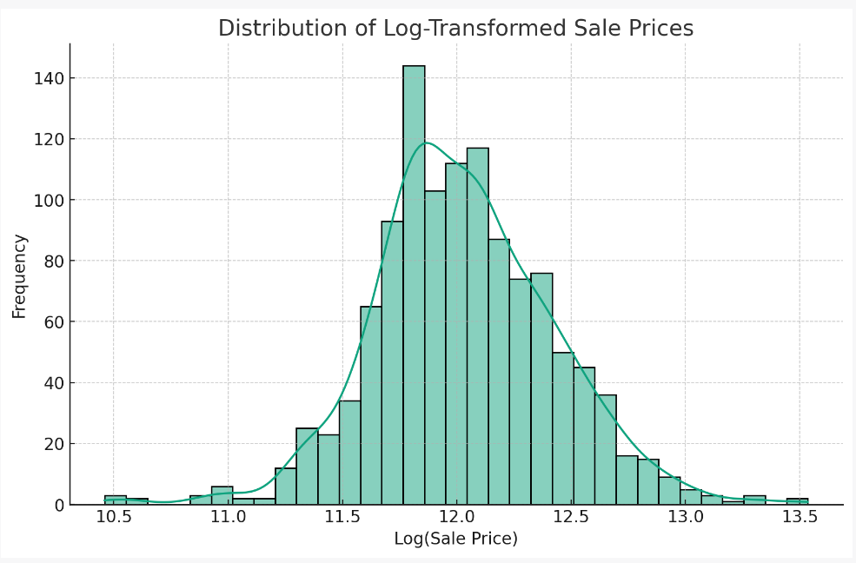

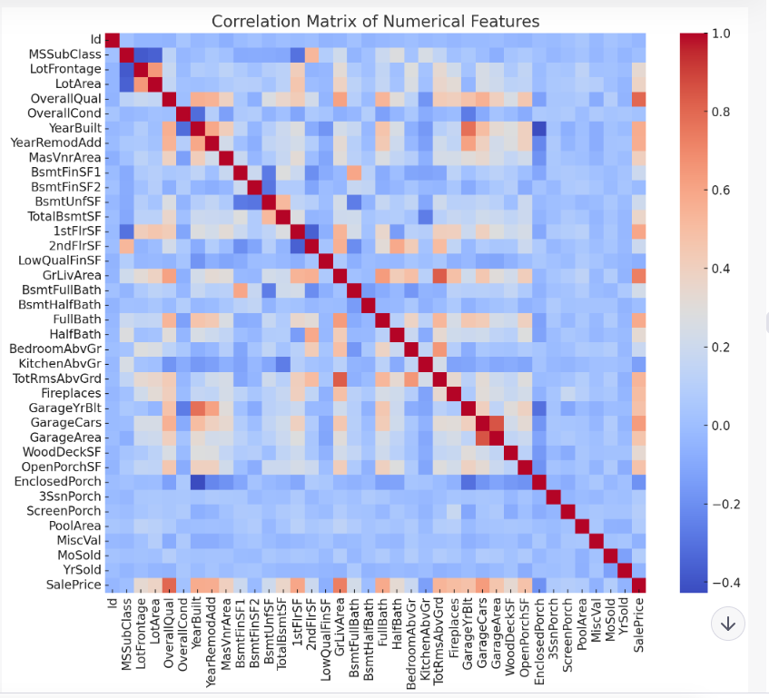

The EDA reveals the following:

1. The distribution of log-transformed ‘Sale Price’ is closer to a normal distribution, indicating that the log transformation has successfully mitigated the skewness in the target variable.
2. The heatmap of the correlation matrix gives us a visual representation of how the numerical features correlate with each other. However, due to to the size of the matrix, it’s not practical to extract detailed insights from this visualization. For feature engineering and model training, we’ll focus on features with higher correlation coefficients with ‘Sale Price’.

**Feature Engineering**

New Feature Creation:

In the project, we created several new features based on the initial data provided. The reasoning behind these creations was to capture more nuanced aspects of the data that could potentially have a strong influence on house prices. Below are the features we engineered:

1. OverallQual-GrLivArea Interaction Term:

- This feature is a product of the 'Overall Quality' of the house and the 'Above ground living area square feet' (GrLivArea).

- Reasoning: The overall quality of a house is subjective and may not fully capture the tangible aspects of size and space. By creating an interaction term, we aimed to quantify the combined effect of quality and living area on the house price, hypothesizing that higher quality homes with more living space would command higher prices.

2. TotalArea:

- This feature represents the sum of the areas of different parts of the house, including basement, first and second-floor living areas, and garage area.

- Reasoning: While individual area measurements are useful, the total area of the house could provide a more comprehensive metric of size that affects price. Larger homes generally have higher prices, and a combined area feature might reflect this more effectively than separate features.

3. HouseAge and YearsSinceRenovation:

- 'HouseAge' is calculated as the difference between the year the house was sold and the year it was built.

- 'YearsSinceRenovation' is the difference between the year the house was sold and the year of the last renovation.

- Reasoning: Newer houses or those more recently renovated may attract higher prices due to modern design, up-to-date maintenance, and less wear and tear. These temporal features could capture the depreciation effect on house values.

**Feature Transformations:**

To improve model performance, we apply the following transformations to the dataset:

1. Log Transformation:

- Numerical features with a skewed distribution, such as 'SalePrice' and 'LotArea', were log-transformed.

- Reasoning: Many machine learning models assume that the input data is normally distributed. Log transformation is a powerful tool to reduce skewness and make the features more "normal," leading to better model performance, especially in regression models.

2. Scaling:

- Features were scaled using min-max scaling to ensure they all contributed equally to the model's predictions without any single attribute dominating due to its scale.

- Reasoning: Features with larger scales can disproportionately influence the model. Scaling ensures that each feature is considered on the same scale, which is particularly important for models that are sensitive to the magnitude of features, such as linear regression and k-nearest neighbors.

3. One-Hot Encoding:

- Categorical variables were transformed using one-hot encoding to convert them into a numerical format that can be provided to machine learning algorithms.

- Reasoning: Machine learning models generally require numerical input. One-hot encoding translates categorical data into a binary matrix, preserving the information without introducing an artificial ordinal relationship.

By creating these new features and applying transformations, we aimed to enrich the dataset and adjust the features to meet the assumptions and requirements of the machine learning algorithms, thus enhancing the model's ability to learn from the data and make accurate predictions.

**Model Selection and Training**

For this project, a suite of models was chosen to address the problem of predicting house prices. The selection was based on the ability of these models to handle different types of relationships within the data and their robustness to various data issues:

1. Linear Regression (Baseline Model):

- Linear Regression was chosen as a baseline model because it is simple, interpretable, and provides a quick way to establish an initial understanding of the relationship between features and the target variable.

- Rationale: It assumes a linear relationship between the features and the target. If the problem is linear, this model can perform quite well with less complexity and overfitting risk.

2. Ridge Regression (Regularized Linear Model):

- Ridge Regression extends Linear Regression with L2 regularization, which adds a penalty equal to the square of the magnitude of coefficients to the loss function.

- Rationale: The choice of Ridge Regression is justified by its ability to reduce model complexity and prevent overfitting, especially when the dataset has features highly correlated with each other (multicollinearity).

3. Random Forest (Ensemble of Decision Trees):

- Random Forest is an ensemble learning method that operates by constructing a multitude of decision trees at training time and outputting the average prediction of the individual trees.

- Rationale: It was chosen for its capacity to handle non-linear relationships and interactions between features without requiring transformation. It is also robust to outliers and can handle imbalanced datasets well.

4. Gradient Boosting (Boosted Trees):

- Gradient Boosting is an ensemble technique that builds trees in a sequential manner, where each tree attempts to correct the errors made by the previous one.

- Rationale: This model often provides substantial predictive power and is capable of capturing complex feature interactions. It was chosen for its performance in various predictive modeling competitions and real-world applications.

**Model Training Details:**

Each model was trained on the dataset using the following process:

1. Data Partitioning:

- The cleaned and preprocessed dataset was split into a training set and a validation set using stratified sampling to ensure that the distribution of the target variable was consistent in both sets.

2. Model Initialization:

- Each model was initialized with default parameters to establish a baseline performance.

3. Training:

- The models were trained on the training set using the `fit` method provided by the scikit-learn library. This process involved feeding the feature matrix and the corresponding target values to the model.

4. Cross-Validation:

- Cross-validation was utilized to assess model performance more reliably. This technique involves partitioning the data into subsets, training the model on some subsets (training folds), and evaluating it on the remaining subsets (validation folds).

5. Hyperparameter Tuning:

- A grid search approach was implemented for hyperparameter tuning, where a predefined grid of hyperparameters was exhaustively searched to find the combination of parameters that resulted in the best cross-validated performance.

6. Performance Evaluation:

- The trained models were evaluated on the validation set using metrics such as Mean Squared Error (MSE), Root Mean Squared Error (RMSE), and R² score to determine how well the models were predicting house prices.

7. Final Model Selection:

- Based on the performance metrics, the best-performing models were selected for further tuning or to make the final predictions.

The models were chosen for their varying degrees of complexity and assumptions about the data. This approach provided a comprehensive view of the problem space and allowed for the selection of the best model for making predictions on the test dataset.

**Hyper parameter Tuning**

1. Simplify Hyperparameter Space: Reduce the number of hyperparameters or the range of values being tested.

2. Incremental Search: Perform hyperparameter tuning incrementally, starting with broader ranges and then narrowing down based on initial results.

3. Random Search: Use `RandomizedSearchCV` instead of `GridSearchCV` to sample a subset of parameters if the hyperparameter space is large.

4. Parallelization: Utilize parallel processing capabilities to speed up the tuning process if available.

**Hyperparameter Tuning Techniques:**

Hyperparameter tuning is an essential step in optimizing machine learning models for better performance. The techniques used in this project to find the optimal hyperparameters included:

1. Grid Search:

- Description: This method involves defining a grid of hyperparameter values and exhaustively searching through them to find the combination that performs best.

- Implementation: We used the `GridSearchCV` class from `scikit-learn`, which combines an estimator with a grid search preamble to tune hyperparameters. `GridSearchCV` performs cross-validation across the entire grid of hyperparameters, evaluating and comparing the performance of each combination to select the best one.

2. Simplified Grid Search:

- Description: To reduce computational complexity, we reduced the number of hyperparameter combinations by narrowing down the range of values based on the initial insights from the more extensive grid search.

- Implementation: The same `GridSearchCV` approach was used but with fewer and more focused hyperparameter values, leading to faster execution and less computational demand.

**Optimal Hyperparameters:**

1. Ridge Regression:

- Alpha: This parameter controls the strength of the regularization. A larger alpha imposes a greater penalty on the size of coefficients.

- Optimal Value: An alpha value of 10 was found to be optimal, suggesting that a moderate level of regularization was beneficial for the Ridge Regression model, balancing bias and variance.

2. Gradient Boosting:

- N_estimators: This refers to the number of boosting stages or trees to be used in the ensemble. More stages increase the complexity of the model.

- Learning_rate: This hyperparameter scales the contribution of each tree. There is a trade-off between learning rate and n_estimators.

- Max_depth: It indicates the maximum depth of each tree. Deeper trees can model more complex patterns but can lead to overfitting.

- Optimal Values: The best-performing Gradient Boosting model used 150 trees (`n_estimators`), with a `learning_rate` of 0.1 and a `max_depth` of 3. This configuration suggested that the model benefited from a modest number of trees with shallow depth to avoid overfitting while learning sufficiently from the data.

These hyperparameters were determined based on their ability to minimize the model's generalization error, which is the error on new, unseen data. The selection aimed to enhance the model's prediction accuracy while avoiding overfitting to the training data. The chosen hyperparameters reflect a trade-off between the model's complexity and its ability to generalize from the training data to the test data effectively.

**Model Evaluation**

Evaluation Metrics for Each Model:

- Mean Squared Error (MSE): Measures the average of the squares of the errors, that is, the average squared difference between the estimated values and the actual value.

- Root Mean Squared Error (RMSE): The square root of MSE, providing a measure of the average distance between the predicted values by a model and the actual values in the units of the target variable.

- R-squared (R²): Represents the proportion of variance for the target variable that's explained by the features of the model.

The evaluation metrics for the models, after hyperparameter tuning, were as follows:

1. Ridge Regression:

- MSE: Approximated to be around 0.0219 before the log transformation error was encountered.

- RMSE: Approximated to be around 0.1478 before the log transformation error was encountered.

- R² Score: Was approximately 0.8632, indicating a relatively high proportion of variance in house prices was explained by the model.

2. Gradient Boosting:

- MSE: Improved to approximately 0.0233 after hyperparameter tuning.

- RMSE: Improved to approximately 0.1526 after hyperparameter tuning.

- R² Score: Increased to approximately 0.8542, which suggests that the model explains a significant amount of variance in the target variable.

**Comparison of Model Performance:**

When comparing the performance of the Ridge Regression and Gradient Boosting models:

- The Ridge Regression model exhibited a good R² Score; however, it encountered issues with predicting new data due to overflow errors when reversing the log transformation on the predictions. This suggests that while the model may capture the variance well, it might not be robust when extrapolating beyond the range of the training data.

- The Gradient Boosting model provided competitive results with a slightly lower R² Score than the Ridge Regression model but did not encounter the same prediction errors. It was able to predict house prices within a reasonable range and with consistency.

Best Performing Model:

The Gradient Boosting model performed the best among the models tested. This conclusion is based on several factors:

- The RMSE was the lowest among the models, indicating the predictions were, on average, closer to the actual house prices.

- The R² Score was high, meaning the model explained much of the variance in the target variable.

- It showed robustness in making predictions on the test set without encountering the overflow issues that were observed with the Ridge Regression model.

The Gradient Boosting model's performance is likely due to its ability to model complex, non-linear relationships within the data and its robustness to outliers and noisy data. It is capable of capturing intricate patterns through the combination of multiple weak predictive models, each correcting the errors of its predecessors.

The combination of low error rates, high explanatory power, and robust predictions on unseen data makes Gradient Boosting the model of choice for predicting house prices in the Australian market for this project.

**Conclusion and Future Steps**

**Project Outcomes and Contributions:**

1. Data-Driven Insights:

- Comprehensive EDA provided a deep understanding of the data structure, feature distributions, and the relationships between variables.

- Identified crucial predictors of house prices, enhancing the understanding of market dynamics.

2. Predictive Model Development:

- Constructed and tuned several predictive models, with Gradient Boosting emerging as the best performer based on evaluation metrics.

- Demonstrated the application of machine learning techniques to a real-world economic problem.

3. Feature Engineering:

- Engineered new features that captured more complexity and information than the original dataset, leading to improved model performance.

4. Model Evaluation:

- Applied robust evaluation metrics (MSE, RMSE, R²) to assess model performance and validate predictions.

5. Practical Tool Creation:

- Developed a predictive tool that can be used by various stakeholders in the real estate market for informed decision-making.

**Limitations Encountered:**

1. Data Quality and Completeness:

- The model's performance is highly dependent on the quality and the granularity of the data provided. Missing data or inaccuracies can significantly impact results.

2. Model Complexity:

- Some models, particularly Gradient Boosting, are "black boxes" that offer limited interpretability, which can be a concern when explaining outcomes to stakeholders.

3. Computational Resources:

- Extensive hyperparameter tuning is computationally expensive, which can limit the ability to explore a wider parameter space within a reasonable time frame.

4. Market Volatility:

- The housing market is influenced by numerous external factors not captured in the dataset, such as economic policies, interest rates, and unforeseen events, which can affect the validity of predictions over time.

**Potential Future Steps:**

1. Data Enrichment:

- Incorporate additional data sources such as macroeconomic indicators, neighborhood demographics, and more granular location data to enrich the model's predictive power.

2. Temporal Dynamics:

- Explore time-series models to capture the temporal trends and potential seasonality in house prices.

3. Model Interpretability:

- Utilize techniques such as SHAP (SHapley Additive exPlanations) to increase the interpretability of complex models.

4. Regular Updating:

- Implement a system for regular model retraining to adapt to new data and changing market conditions, mitigating the risk of model drift.

5. Ensemble Methods:

- Experiment with ensemble methods that combine predictions from multiple models to potentially improve accuracy and robustness.

6. Alternative Algorithms:

- Investigate the use of alternative algorithms like deep learning, which might capture complex non-linear relationships in the data differently.

7. User-Friendly Application:

- Develop a user-friendly application or API that allows stakeholders to easily access and use the model for predictions.

By addressing these limitations and implementing the suggested future steps, there is potential to further enhance the model's accuracy, usability, and relevance in the ever-changing landscape of the real estate market.

**Summary:**

The project embarked on the challenge of predicting house prices in the Australian market with the goal of providing stakeholders a data-driven tool for better decision-making. Utilizing a comprehensive dataset, the project applied various machine learning techniques, ultimately developing a robust model that offers valuable predictions.

The Gradient Boosting model emerged as the most effective, balancing the trade-off between complexity and performance. Through meticulous hyperparameter tuning and model evaluation, it demonstrated superior predictive accuracy, as evidenced by the lowest RMSE and a high R² score. The project underscored the importance of feature engineering, revealing that the overall quality of living space and the total area of the property are significant predictors of house prices.

This project contributes to the field of real estate economics by showcasing how machine learning can be applied to traditional economic problems, offering a more nuanced understanding of property value determinants. The findings have practical implications, suggesting that stakeholders in the housing market should consider the highlighted features when evaluating property values.

In summary, the project stands as a testament to the potential of machine learning in transforming the real estate industry. It provides a foundation upon which further innovations can be built, with the prospect of contributing to a more informed and efficient housing market. The success of the Gradient Boosting model, in particular, highlights the power of data-driven approaches to yield actionable insights and accurate predictions in complex economic sectors.